[E120] MCU panel

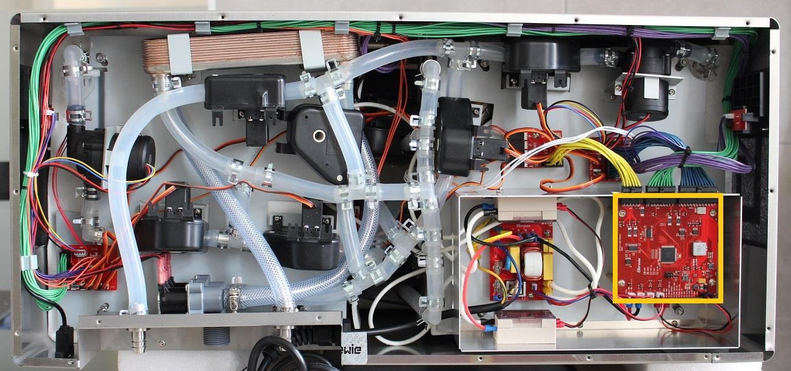

Disconnect all the cables and unscrew the screws holding the MCU unit.

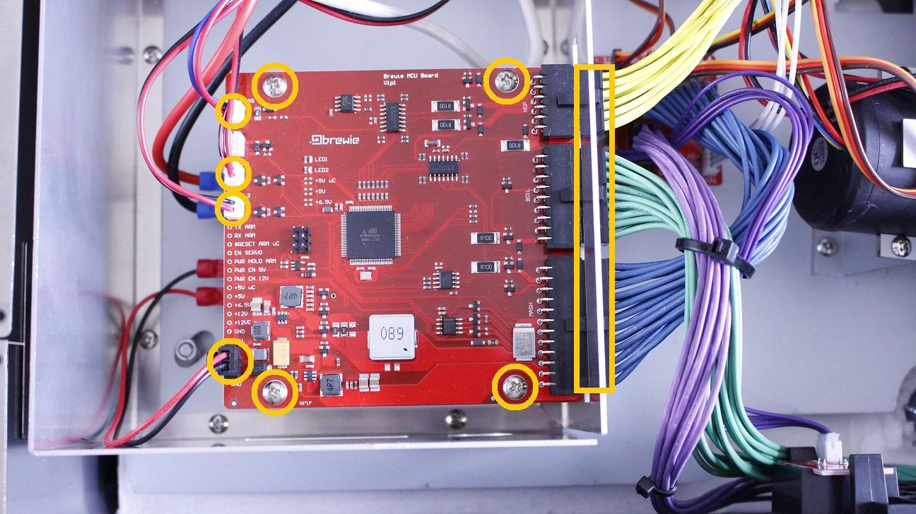

The MCU can be removed now.

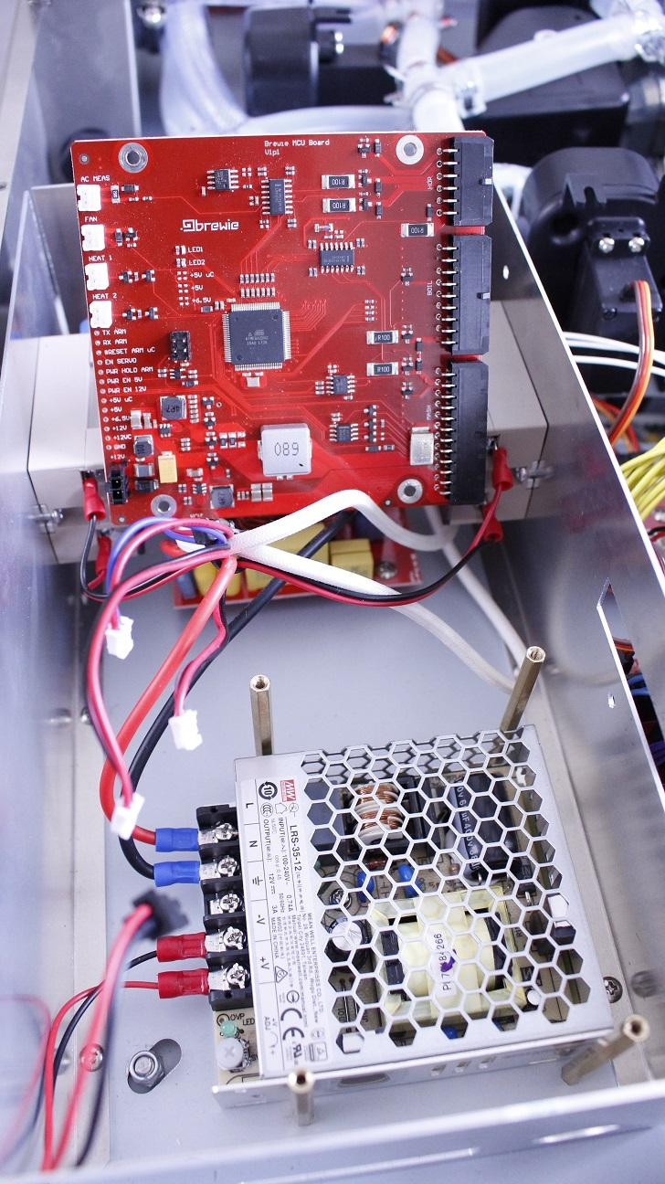

Reassemble consists of the same steps in reverse.